Business CareWare


Auto Emails Configured Per Customer Site
How To Document

Document Changes

Date | Version | Change Description | Changed By
19/12/2016 | 1.0 | Original Version | TT
12/01/2017 | 1.1 | Added examples of AutoEmails | TT
24/01/2017 | 1.2 | Added new AutoEmail layout for Simmons and Simmons | TT

Table of Contents
1 Introduction 3
2 Implementations 4
3 Examples of Each AutoEMail 5
3.1 AEFCXL – SHU 5
3.2 AEFUPD – Clayton Utz (Layout 2) 5
3.3 AEFUPD – SHU (Layout 1) 6
3.4 AEFFFC – SHU 6
3.5 AEFPBK – SHU 7
3.6 AEFECC – SHU 7
3.7 AEFCON – SHU (Layout 1) 8
3.8 AEFCON – Simmons and Simmons (Layout 3) 8
3.9 AEFUIE – SHU 9
3.10 AEFUPE – SHU 9
3.11 AEFSFD – SHU 10
3.12 AEFPRQ – SHU 10
3.13 AEFDOB/AEFDB2 – SHU 10
3.14 AEFCHN – SHU 11
3.15 AEFDRM – PwC Oz 11
3.16 AEFSTC – PwC Oz 12
3.17 AEFSWR – PwC Oz 12

Introduction

This document provides a description of which Autoemails have been configured at each customer site. The latest Autoemail component is based on the implementation for Project Phoenix.

Note: There are other Autoemail implementations at customer sites but these are not described in this document.

There are examples of each autoemail that can currently be produced in section 3.

Implementations

AutoEmail | Description | SPROC | SHU | PWC Oz | Clayton UTZ | Simmons and Simmons | Notes
AEFCXL | Booking Cancellation | CABS_AEF_SEND_CXL |  | x | x | x
AEFUPD | Booking Updates | CABS_AUTO_EMAIL_FUNCS_SEND | x | x |  | x | Implemented but then removed from SHU
AEFFFC | Feedback From Customer | CABS_AEF_SEND_FFC |  | x | x | x
AEFPBK | Pending Booking | CABS_AEF_SEND_PBK |  | x | x | x
AEFECC | Event Co-Ordinator Change | CABS_AEF_SEND_ECC | x | x | x | x | Implemented but then removed from SHU
AEFCON | Final Confirmation | CABS_AUTO_EMAIL_FUNCS_SEND |  | x | x
AEFUIE | Uninvoiced Events | CABS_AEF_SEND_UIE |  | x | x | x
AEFUPE | Unposted Events | CABS_AEF_SEND_UPE |  | x | x | x
AEFSFD | Summary of All Final Event Details | CABS_AEF_SEND_SFD | x | x | x | x | Implemented but then removed from SHU
AEFPRQ | Porters Required | CABS_AEF_SEND_PRQ | x | x | x | x | Implemented but then removed from SHU
AEFDOB | Deliver to Outer Building | CABS_AEF_SEND_DOB |  | x | x | x
AEFDB2 | Deliver to Outer Building - Update | CABS_AEF_SEND_DOB |  | x | x | x
AEFCHN | Booking Change | CABS_AEF_SEND_CHN | x | x | x | x | Implemented but then removed from SHU
AEFDRM | Individual Booking Reminder | CABS_AEF_SEND_DRM | x |  | x | x
AEFSTC | Booking Status Change | CABS_AEF_SEND_DRM | x |  | x | x
AEFSWR | Summary Weekly Reminder | CABS_AEF_SEND_SWR | x |  | x | x

Examples of Each AutoEMail

AEFCXL – SHU

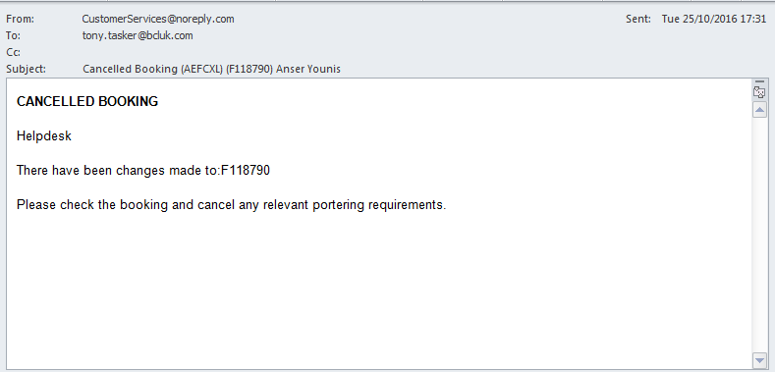
Figure 1 - AutoEmail AEFCXL (SHU)

AEFUPD – Clayton Utz (Layout 2)

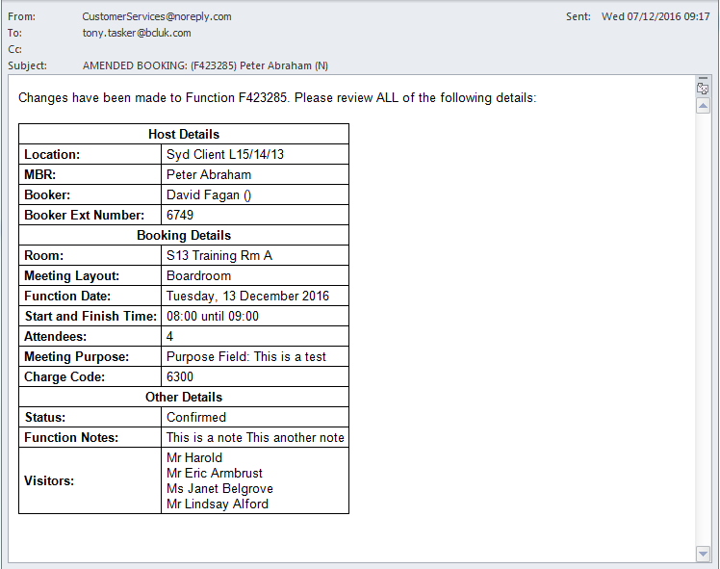
Figure 2 - AutoEmail AEFUPD (Clayton Utz - Layout 2)

AEFUPD – SHU (Layout 1)
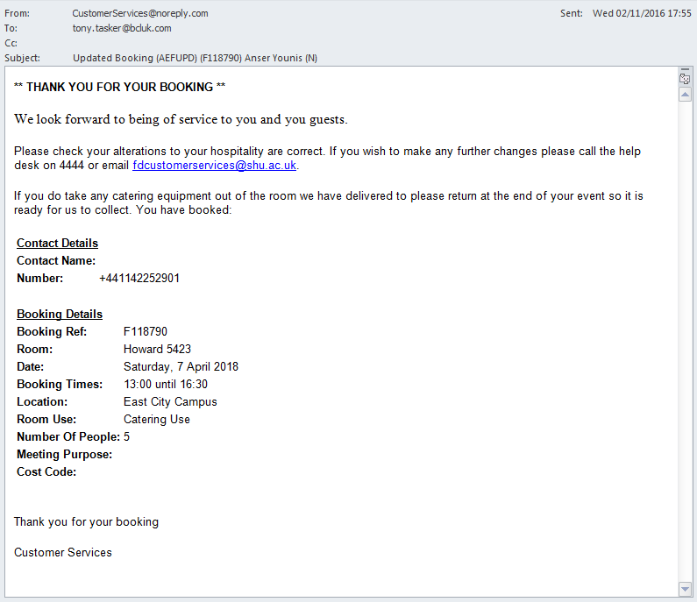
Figure 3 - AutoEmail AEFUPD (SHU - Layout 1)

AEFFFC – SHU
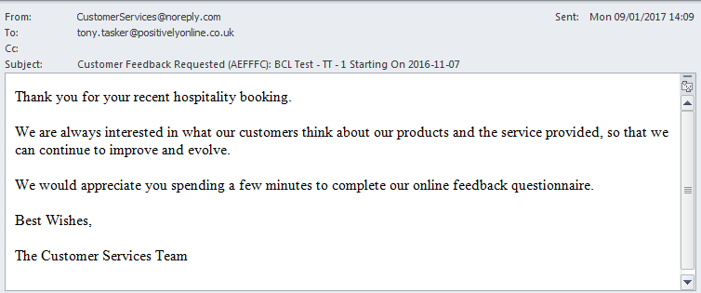
Figure 4 - AutoEmail AEFFFC (SHU)

AEFPBK – SHU

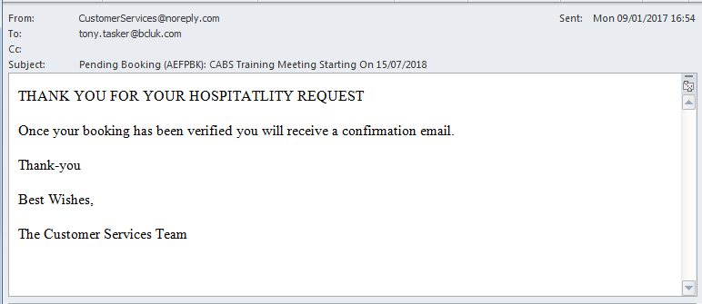
Figure 5 - AutoEMail AEFPBK (SHU)

AEFECC – SHU
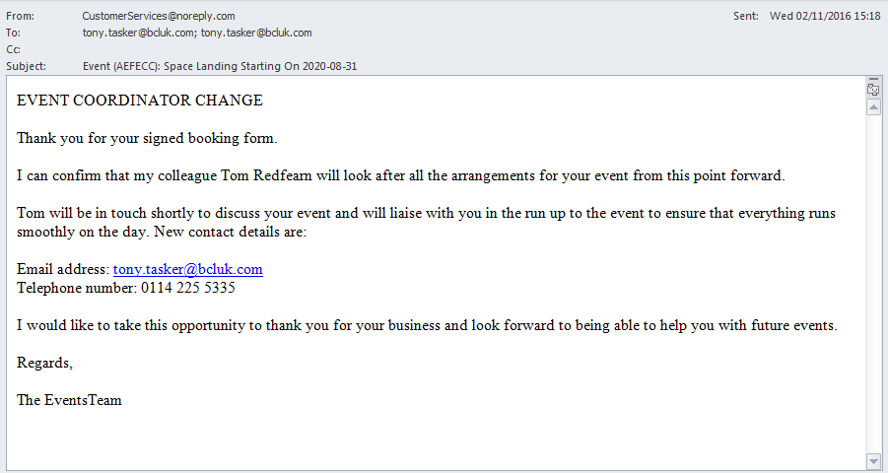
Figure 6 - AutoEmail AEFECC – SHU

AEFCON – SHU (Layout 1)
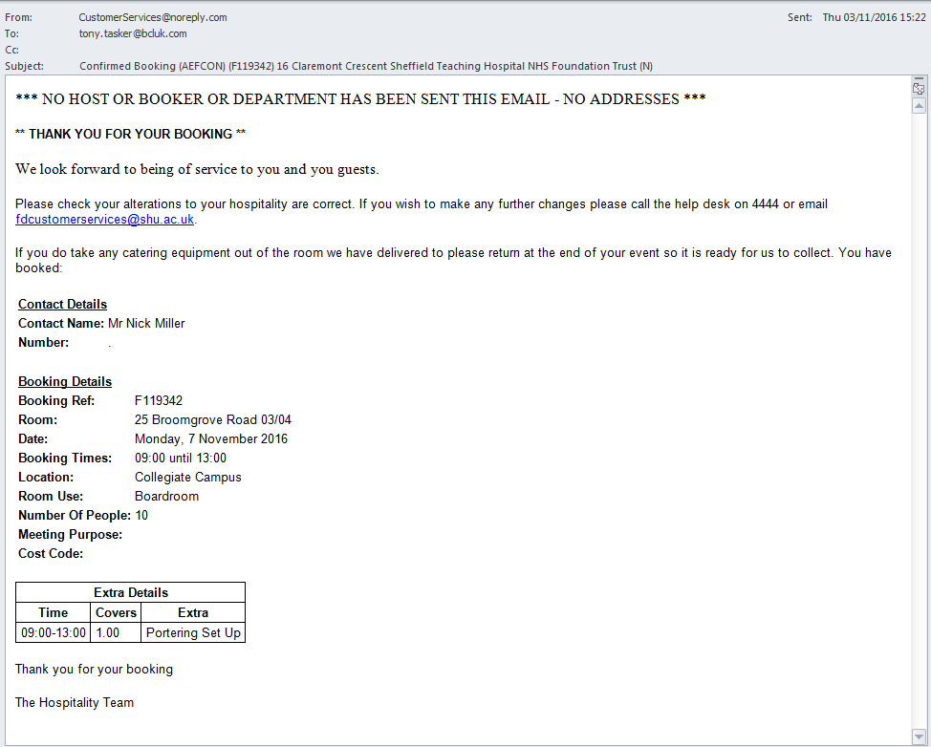
Figure 7 - AutoEmail AEFCON (SHU)

AEFCON – Simmons and Simmons (Layout 3)
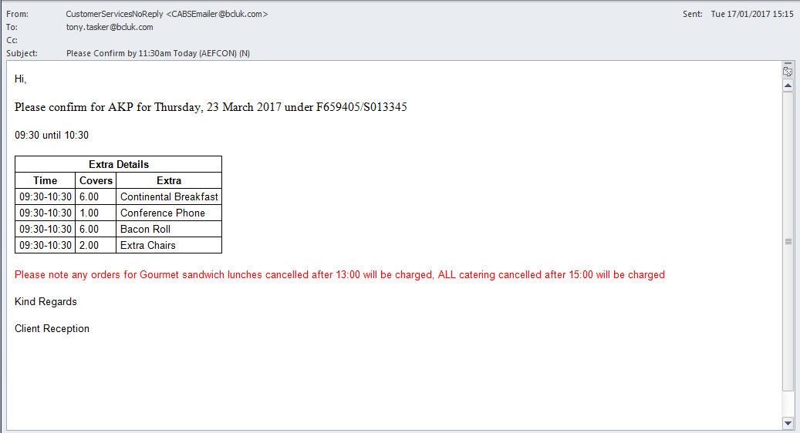
Figure 8 - AutoEmail AEFCON (Simmons and Simmons)

AEFUIE – SHU
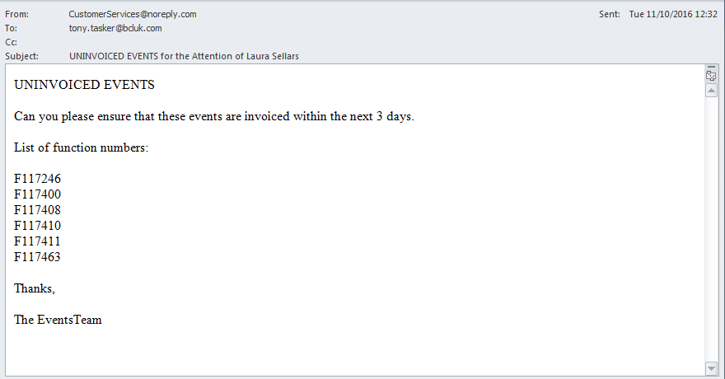
Figure 9 - AutoEmail AEFUIE (SHU)

AEFUPE – SHU
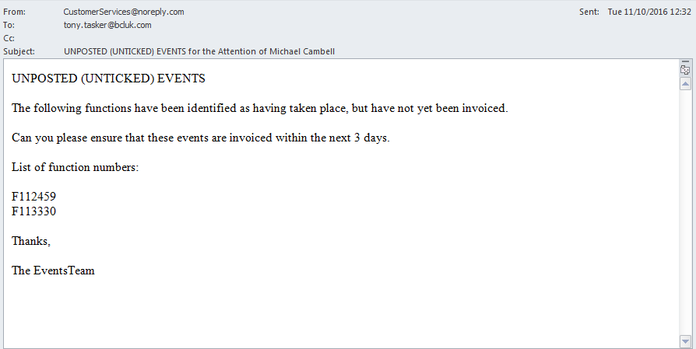
Figure 10 - AutoEmail AEFUPE (SHU)

AEFSFD – SHU
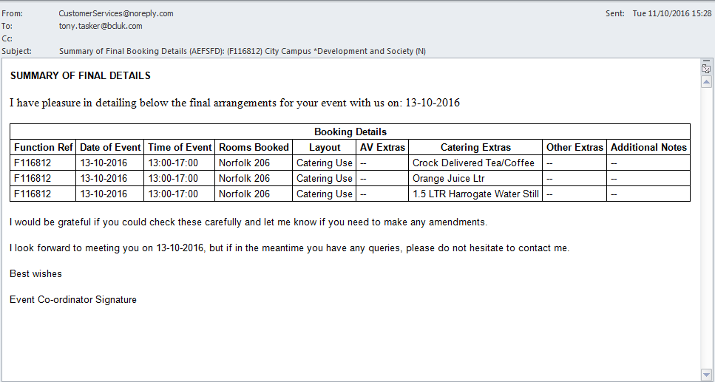
Figure 11 - AutoEmail AEFSFD (SHU)

AEFPRQ – SHU
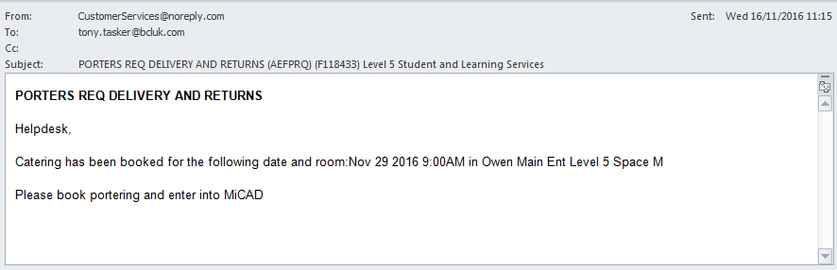
Figure 12 - AutoEMail AEFPRQ (SHU)

AEFDOB/AEFDB2 – SHU
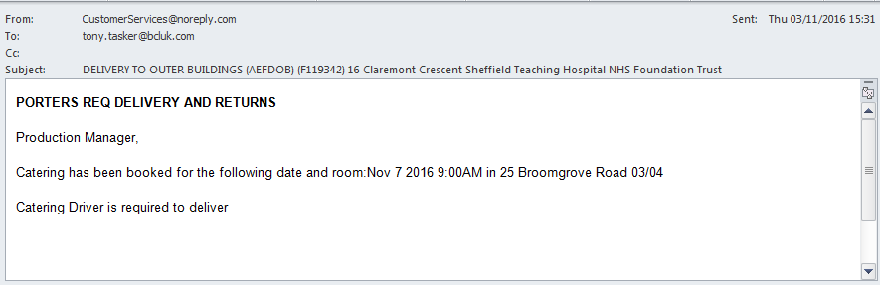
Figure 13 - AutoEMail AEFDOB (SHU)

AEFCHN – SHU
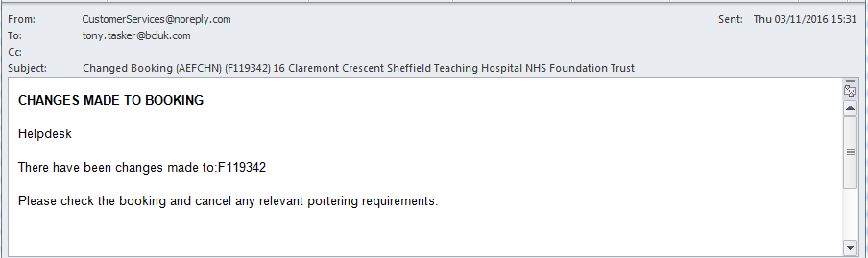
Figure 14 - AutoEMail AEFCHN (SHU)

AEFDRM – PwC Oz
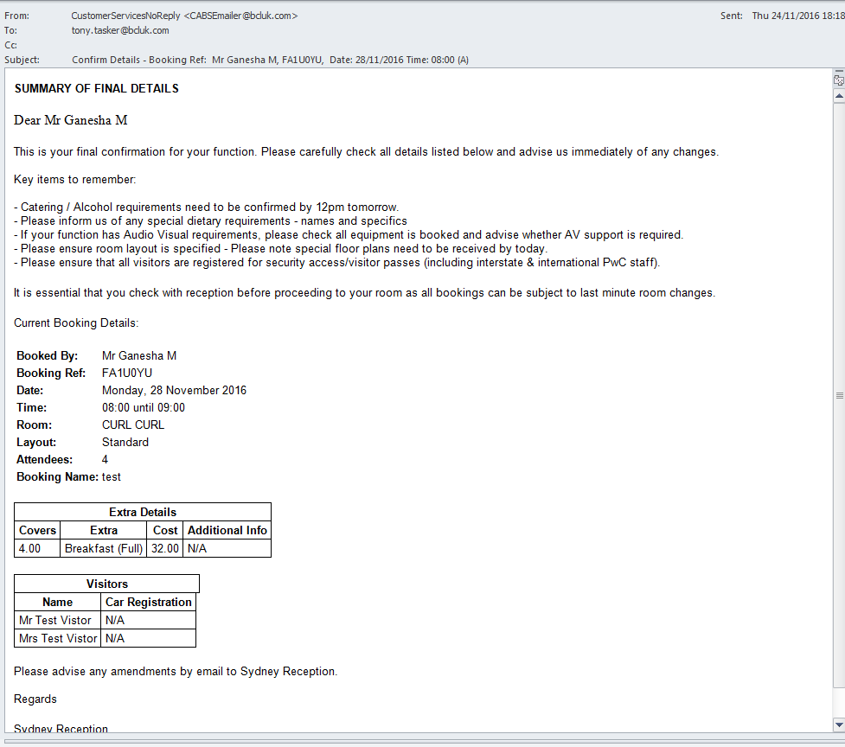
Figure 15 - AutoEMail AEFDRM (PwC Oz)

AEFSTC – PwC Oz
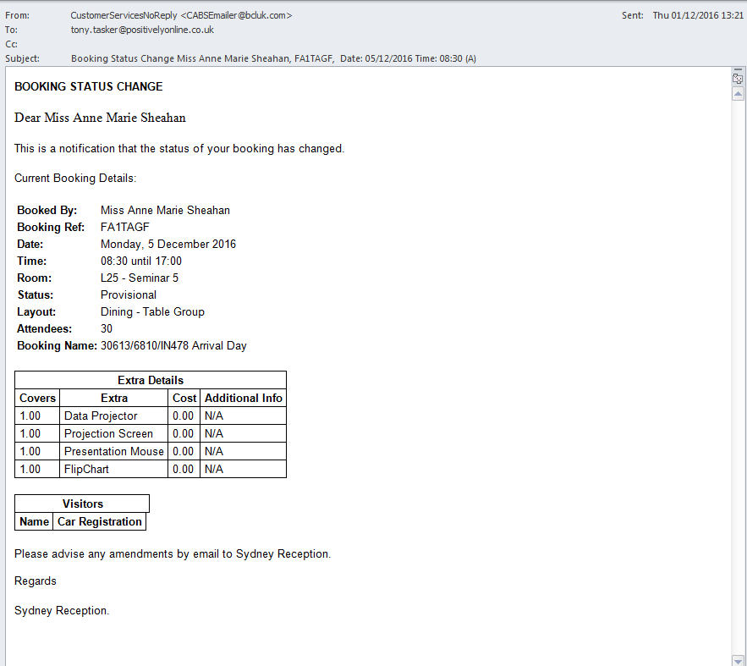
Figure 16 - AutoEmail AEFSTC (PwC Oz)

AEFSWR – PwC Oz

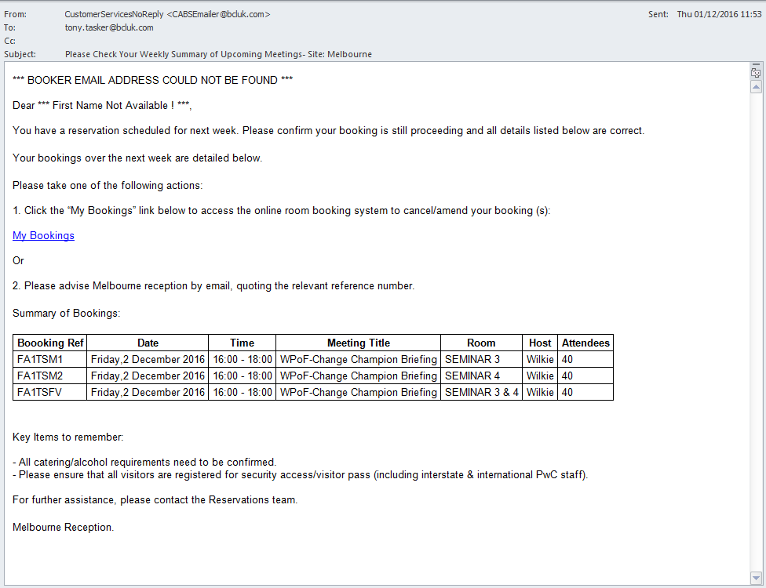
Figure 17 - AutoEail AEFSWR (PwC Oz)

